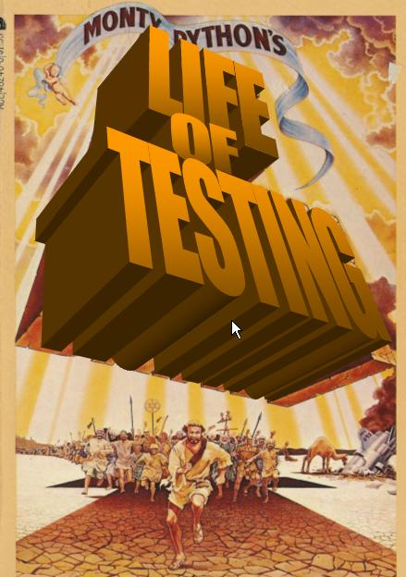

The Life of Testing

Scene: There is a gatekeeper with a checklist. A line of Testers approaches led by a Centurion Program Manager. To the right of the gatekeeper is at least one person already being crucified.
Centurion: Keep in line….Keep in line…
Gatekeeper: Next?
Tester#1 approaches the gatekeeper.
Gatekeeper: Crucifixion?
Tester#1: Yes. A key customer found a defect in a remote workflow on an unsupported hardware and operating system configuration. It happened to coincide with their enterprise renewal and they threatened to not renew. So yes, it’s crucifixion for me since testing did not find this crucial defect.
Gatekeeper: Good. (checks) Out the door, first available cross on your right… Next?
Tester#1 moves off to the right and joins others that are being crucified.
Centurion goes with Tester#1 and helps the Tester get set up on the cross
Tester#2 approaches the gatekeeper.
Gatekeeper: Crucifixion?
Tester#2: Yes. I found a safety critical defect during final cert and didn’t think we should release the software with this defect. Since I’m the one that found this defect it’s crucifixion for me.
Gatekeeper: Good. (checks) Out the door, first available cross on your right… Next?
Tester#2 moves off to the right and joins others that are being crucified.
Documenter approaches the gatekeeper.
Gatekeeper: Crucifixion?
Documenter: Yes. I was assigned to write documentation for a major release which was to provide seamless real-time integration through our entire product line. The developers were all too busy to meet with me, so I based the documentation on the specs. However, the requirements changed without the specs being updated. The final product turned out to be some sort of database for cataloging tropical fish. So crucifixion it is. I’m quite looking forward to it actually.
Gatekeeper: Good. (checks) Out the door, first available cross on your right…. Next?
Documenter moves off to the right and joins others that are being crucified.
Tester#3 approaches the gatekeeper.
Gatekeeper: Crucifixion?
Tester#3: Er…No, its freedom for me sir.
Gatekeeper: What?
Tester#3: Freedom for me….We didn’t get any requirements from the Product Manager and the developers wrote a bunch of crap. So it’s crucifixion for them and freedom for me.
Gatekeeper: Well, that’s jolly good….In that case….
Tester#3: No…No, just kidding. It’s crucifixion for me anyway. Regardless of how much crap the developers write it’s always testing that gets crucified. Everyone knows that.
Gatekeeper: Oh, I see. Very good , veeerry good(ha ha ha)…..Out the door….
Tester#3: Yes, yes. I know the drill. Out the door, first available cross on my right
Tester#3 moves off to the right and joins others that are being crucified. Existing person being crucified begins to speak:

Cue up music just as this line is spoken. There is about a 6 second lead in.

Tester#0: Cheer up, Testers. You know what they say.

Always Look on the Bright Side of Code

Some things in code are bad,
They can really make you mad.
Other things just make you swear and curse.
When you're chewing on life's gristle,
Don't grumble, give a whistle!
And this'll help things turn out for the best...
And...
...always look on the bright side of code!
(whistle)
Always look on the light side of code...
(whistle)

If the code seems jolly rotten,
There's something you've forgotten!
And that's to laugh and smile and dance and sing,
When the program core dumps,
Don't be silly chumps,
Just purse your lips and whistle -- that's the thing!

And... always look on the bright side of code...
(whistle)

Always look on the right side of code...
(whistle)

The Code's a piece of sh!%,
When we look at it.
We can always overlook a minor kink
It probably compiles, it might even link
Surely that must mean it doesn’t stink!

So always look on the bright side of codes!
(whistle)
Just before your user base erodes.
(whistle)

The software costs big bucks,
Thank God the competition sucks
You can always face the users with a patch!
Forget about your sins -- give Support some grins,
Enjoy it – they will love you in dispatch!

And always look on the bright side of code...(whistle)
Always look on the bright side of code…(whistle)
And always look on the bright side of code...(whistle)
Always look on the bright side of code(whistle)

Centurion: Stop the song!.....
Centurion: Stop the song! A couple developers just got back from vacation and have made a few minor changes. We need you all to work over the weekend to verify everything. But the bright side is that we have arranged for your PC’s to be set up here, so there will be no need to get off your crosses.

General grumbling. One tester starts singing again.

Tester#1- Remember testers…Always look on the bright side…

En Masse- Oh shut up!.
Costumes:
- 4 Testers/1 documenter
  - simple white sheet cloth, sandals, chains/ropes if we have them
- 5 lightweight crosses
  - Masonite + cardboard
  - Rope + duct tape
- 1 gatekeeper
  - monk robe
  - 1 clipboard
- 1 centurion
  - Dark black robe
  - whip
- Music to “Always Look on the Bright side of Life”
- Cue cards
- Poster – Life of Testing

Casting

Gatekeeper Todd Little
Centurion: Lee Stone
Tester#0 Holly Hildebrand
Tester#1 L.J Wieting
Tester#2 Gordon Young
Documenter Hays Warden
Tester#3 Jeffrey Miller
Cue Cards Jerry Walters

Cue Cards

