Top 10 Ways that the Agile Development Conference is Agile

10 - We fixed the release date | Oh, by the way, did you enjoy the Ice Breaker?  I have a confession….The committee worked all weekend and what you saw was a demo…If you would just come back in a couple of weeks you had a sense of how great this conference is going to be!
9 - Sustainable Pace | You have 8 drink tickets to be used over the course of the week. Drink responsibly.
8 - We expect change | We utilize Open Space and the Retrospectives as a means of adjusting the program to your needs. If you have a topic that you would like to explore, use the Open Space accordingly. Think of the Friday afternoon Getaway as Wide Open Spaces. That's a song from the Dixie Chicks. I'm from Texas as are the Dixie Chicks and other un-named war lords. But the Getaways provide many opportunities to continue the conversations in a non-traditional manner. Last year people went to snowbird, went hiking, or stayed in the hotel and did some Open Space. We are using the posting board outside the registration area to post ideas of self organizing groups.
7 - Collaboration instead of Negotiation | How many of you realize that we really didn't promise you anything--And you signed up anyway.
6 - Documentation | Who says agilists don't value documentation. See this artifact from the early days of ADC planning.  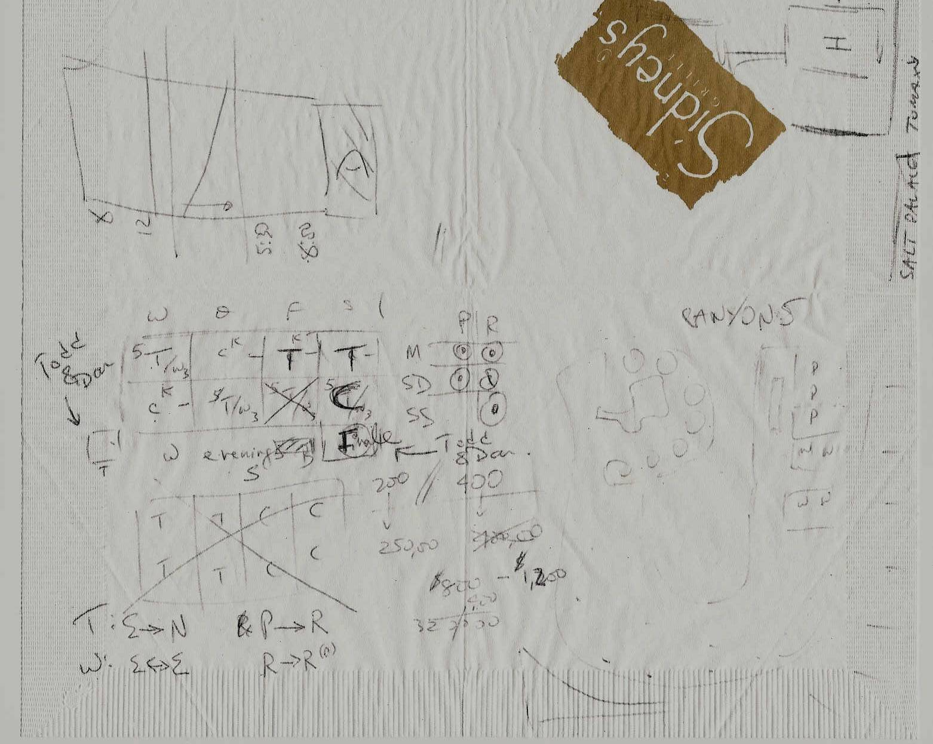
5 - Customer Involvement | We have over 80 people involved in the committee, as presenters, or as volunteers. I wanted to highlight the Experience Reports. We had a great team of people helping with the experience reports and we have 14 papers being presented. In fact I'm giving one on Saturday morning so I encourage you to attend.
4 - People and Interactions | This conference is all about you being involved in the conference. It is about people and conversations. I want to bring particular attention to the Peer to Peer workshops. There may be an impression that this is where the experts go to exchange ideas. There is some truth to that, but novices also can gain a lot from peer to peer workshops.
3 - Collocation | This year we had most of the program committee chairs located in the London area which really helped formulate a cohesive program. Thanks our London chairs: John Daniels, Rachel Davies, Steve Freeman, and Andy Pols.
2 - We have yearly iterative deliveries | And next year we will be merging ADC with XPAU to create an even better agile conference experience. We don't yet have a name, but that is where you have an opportunity to participate. We are calling on the collective creativity of the community to come up with a new name. The winner of the contest will receive a free admission to the 2005 conference.
1 - Metaphor | When I was explaining my conference philosophy to Alistair during the early days of ADC planning, he so brilliantly summed it up as he is prone to do: Oh, you mean "A giant party conveniently collocated with a conference"

